**ANALYSING HOUSING PRICES IN METROPOLITAN**

**AREAS OF INDIA**

1. Introduction

The dynamics of the real estate market in metropolitan areas of India have always been a topic of significant interest and concern for both homeowners and investors. This project aims to shed light on the ever-evolving landscape of housing prices in some of India's key metropolitan regions.

Through a comprehensive analysis, we will explore the trends, variations, and factors influencing housing prices in these urban centers. By utilizing data visualization and analytics tools, particularly Tableau, we will transform raw data into meaningful insights and compelling visualizations.

Our investigation will not only benefit prospective homebuyers and property investors but also provide valuable information for policymakers, real estate professionals, and anyone interested in understanding the complex interplay of factors affecting housing costs in India's bustling metropolises.

Join us on this data-driven journey as we uncover the stories hidden within the numbers, and gain a deeper understanding of the housing market in metropolitan India.

1.1 overview

The primary objective of this project is to gain a comprehensive understanding of housing price trends in the metropolitan areas of India. By leveraging data analysis and visualization techniques, we aim to uncover valuable insights into the factors influencing housing prices, regional variations, and temporal trends.

1.2 Purpose

* Understand Housing Market Trends
* Identify Regional Variation
* Explore Temporal Changes
* Factors Influencing Housing Prices
* Empower Decision-Making
* Policy Recommendations

2. Problem statement & design thinking

The housing market in Indian metropolitan areas lacks accessible, data-driven insights, leading to challenges in decision-making for homebuyers, investors, and policymakers. There is a need for a user-friendly and informative tool to understand housing price trends, regional variations, and the factors influencing these prices.

Clearly outline the project's goal: to provide accessible, data-driven insights into housing prices in Indian metropolises.

Specify the key features and information the project will deliver, such as visualizations, regional comparisons, and factors affecting prices.

2.1 Empathy map

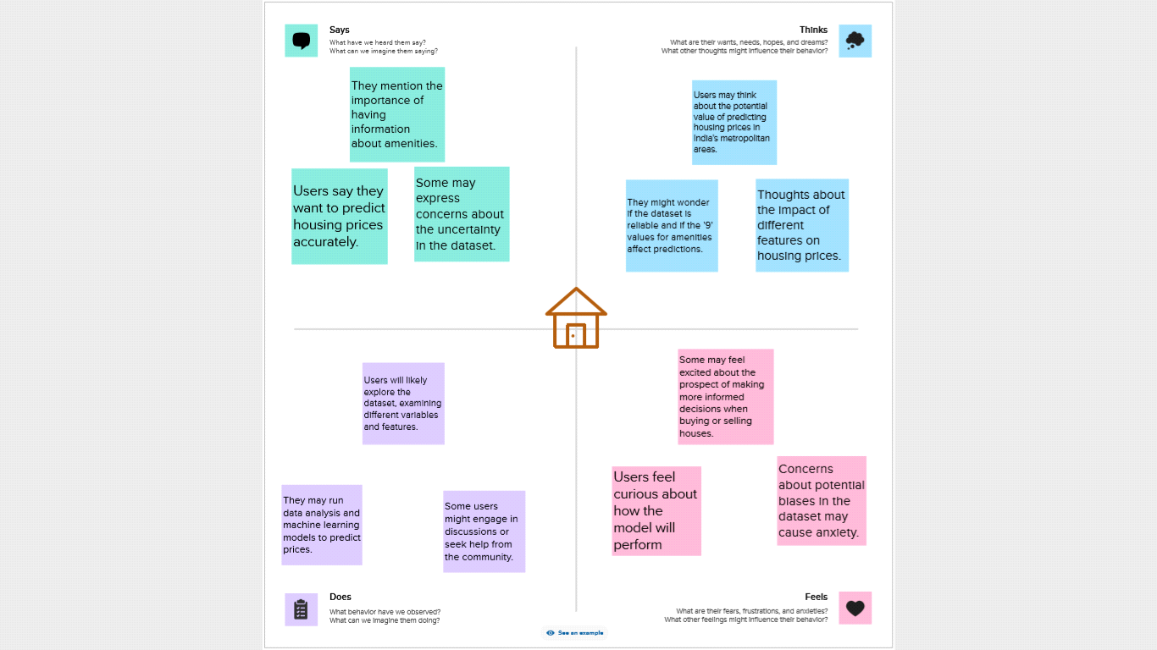

2.2 Brainstorming map

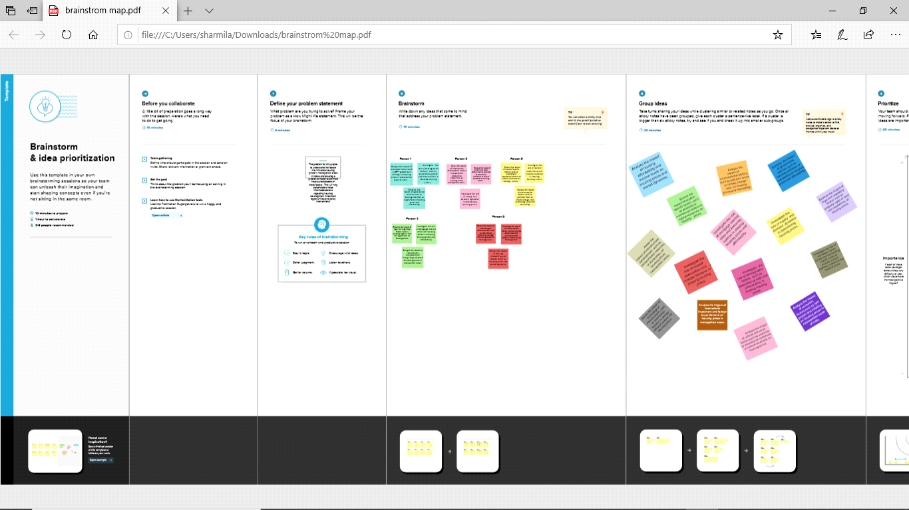

3. Result

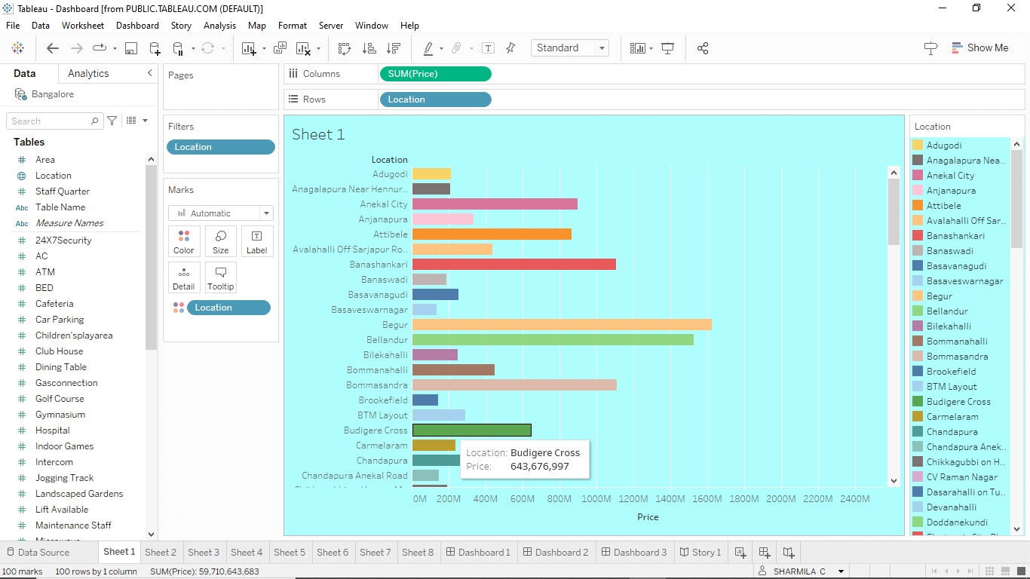

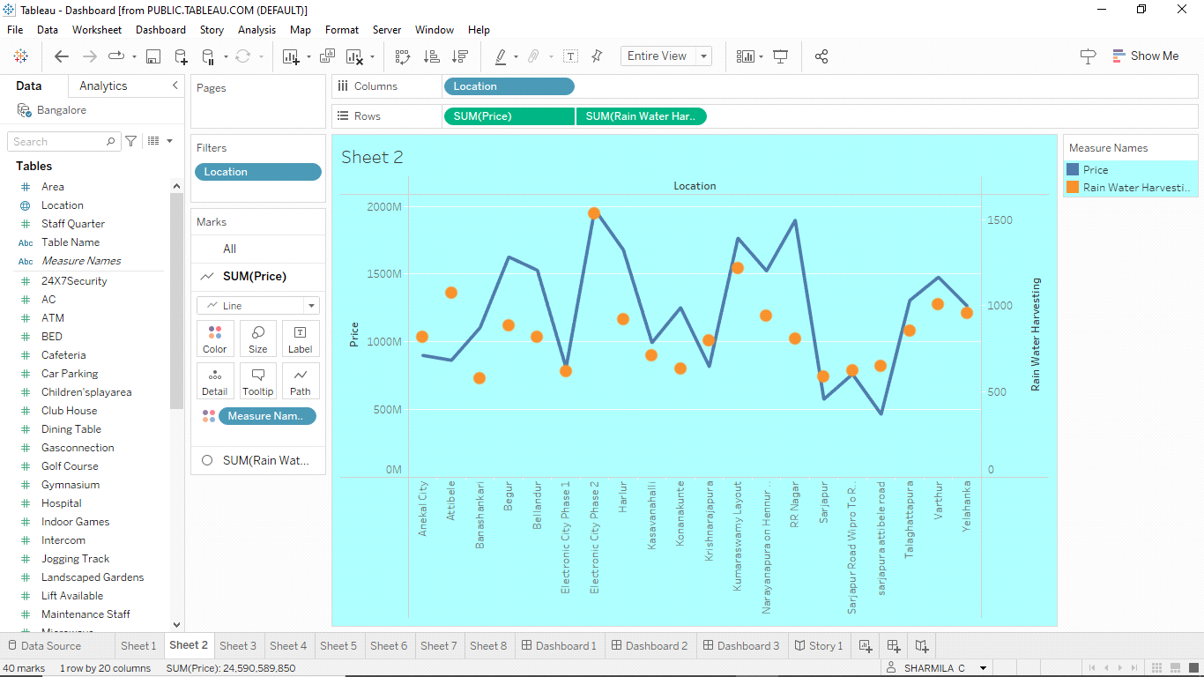

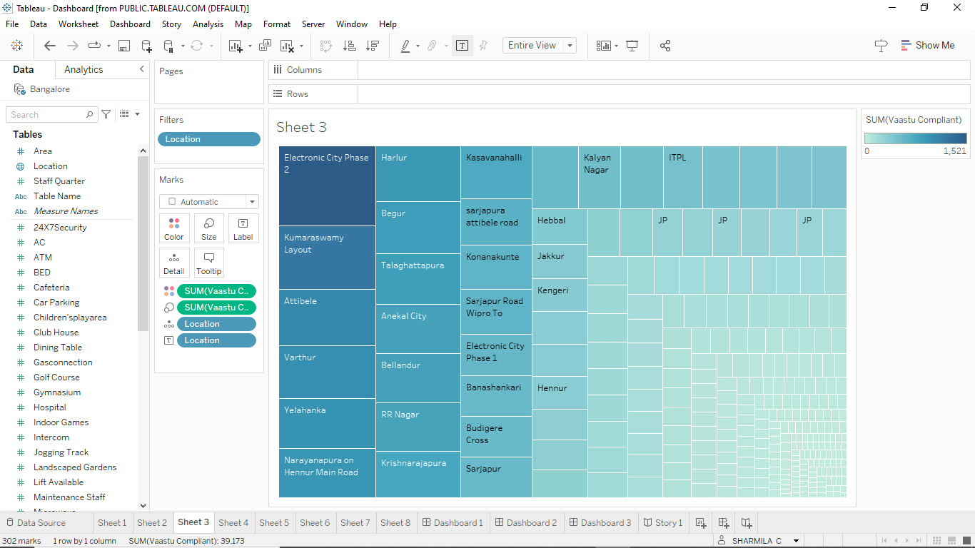

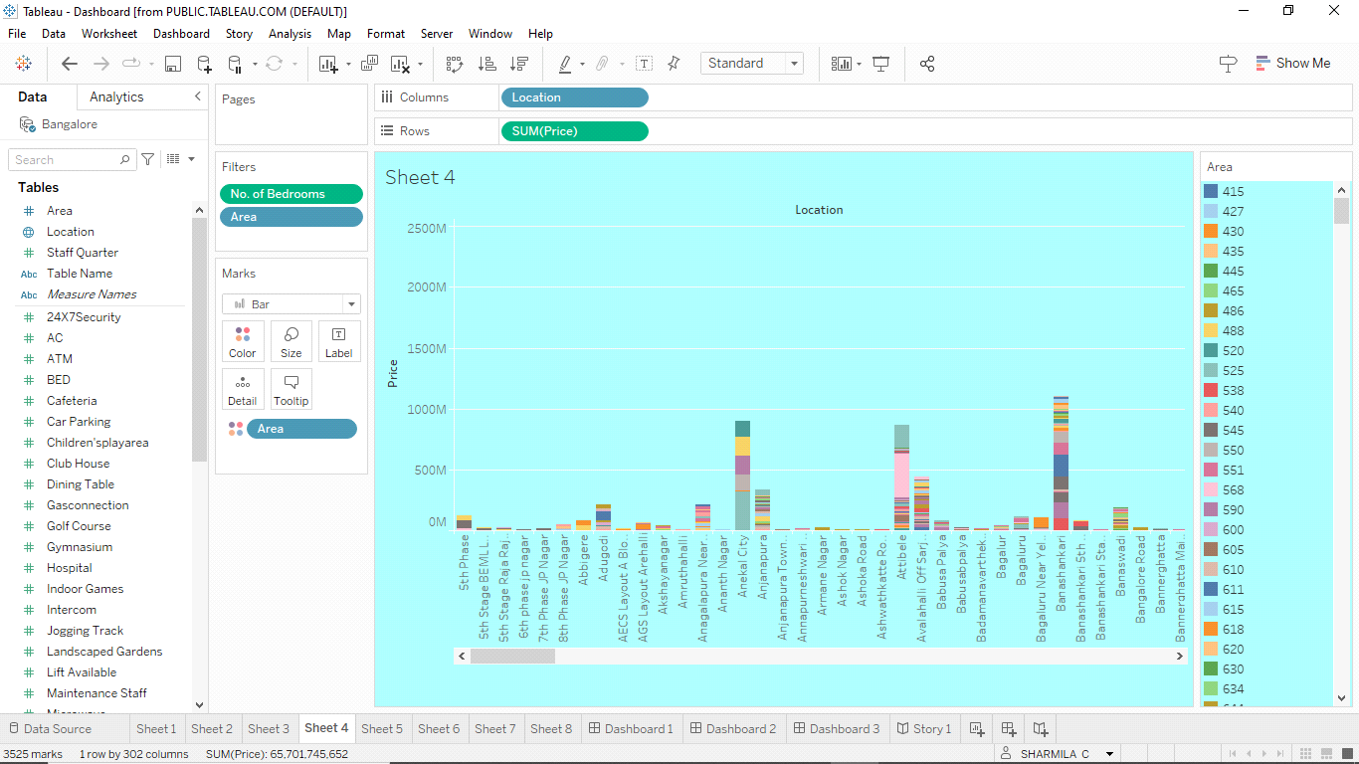

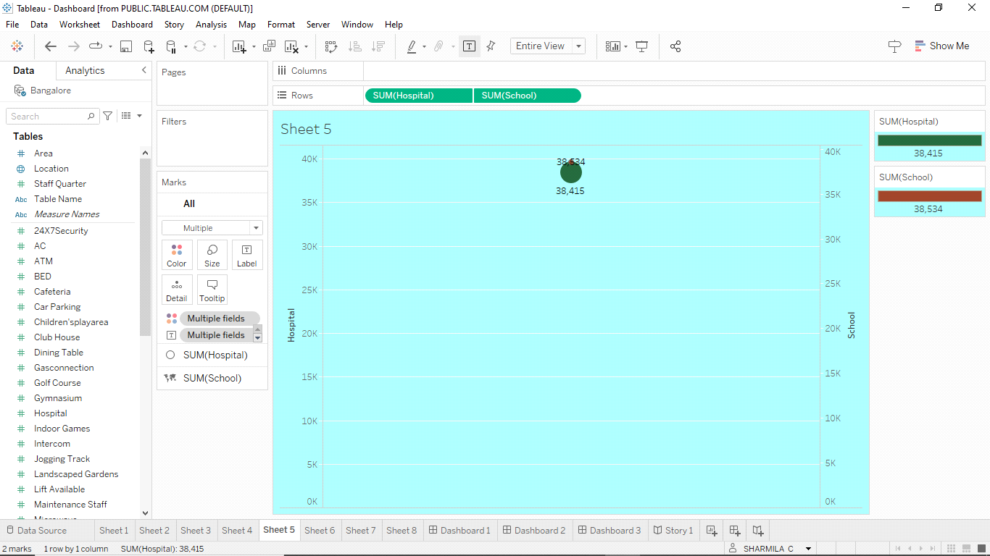

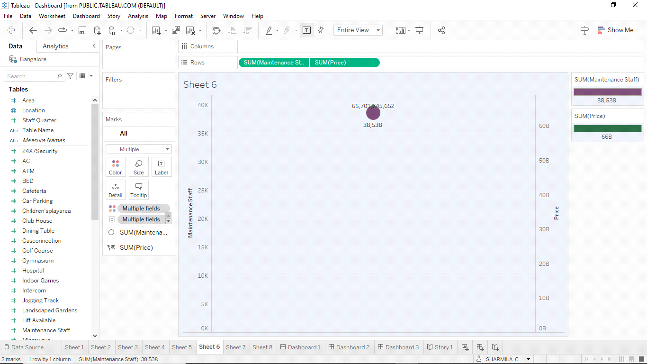

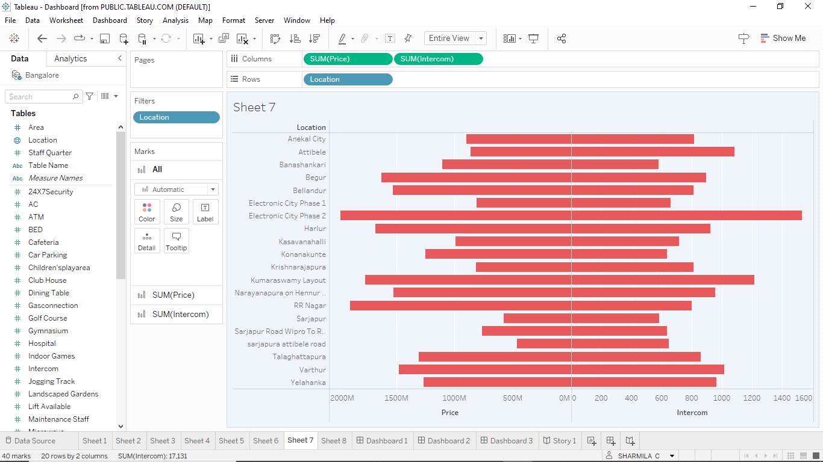

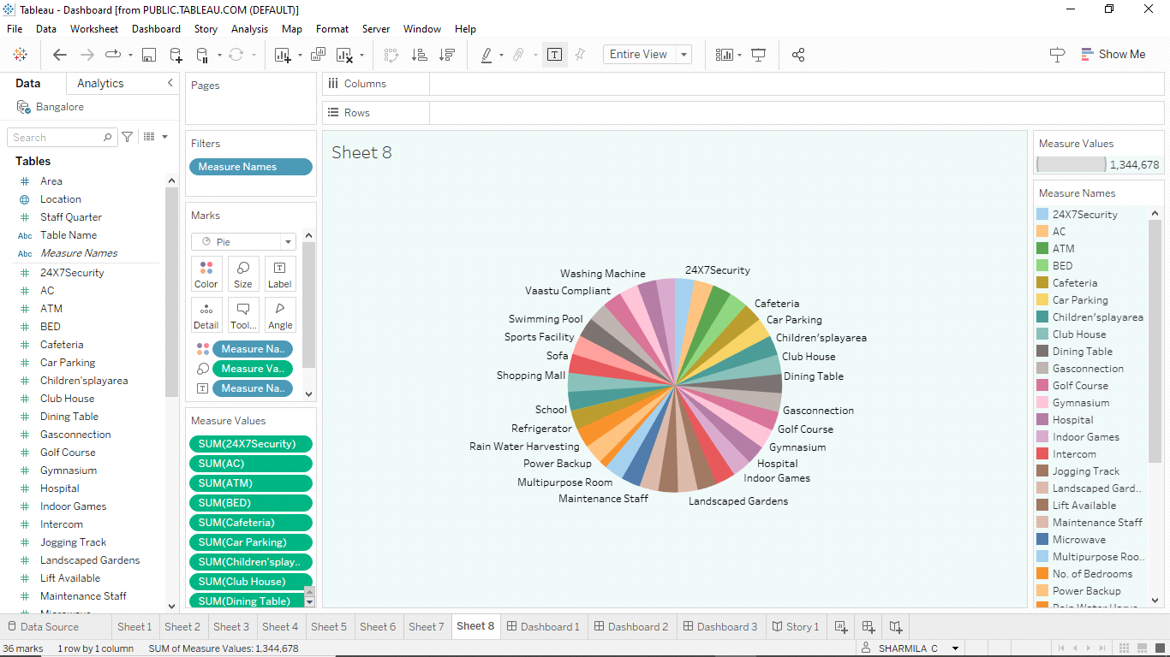

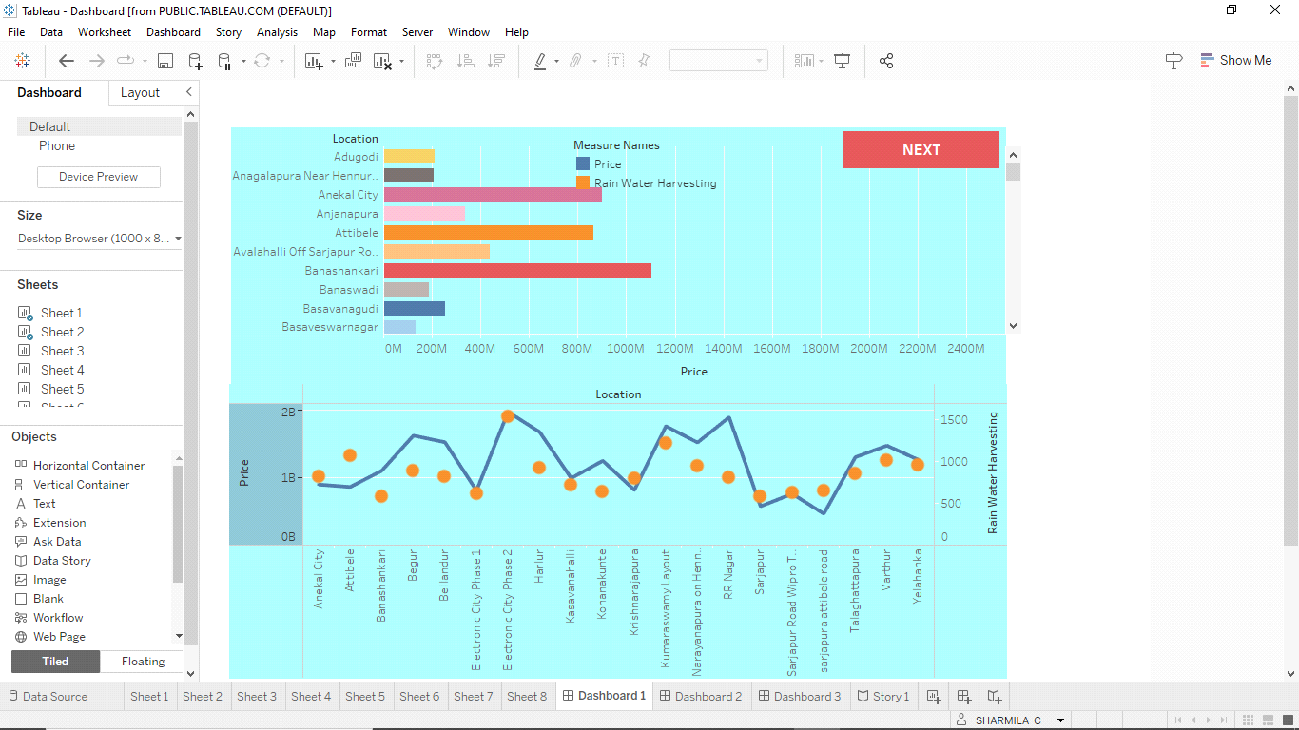

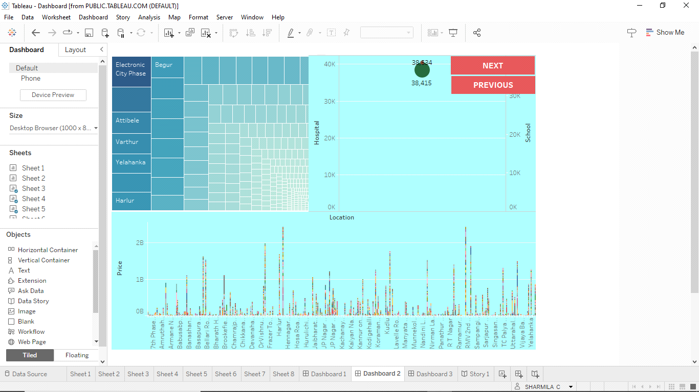

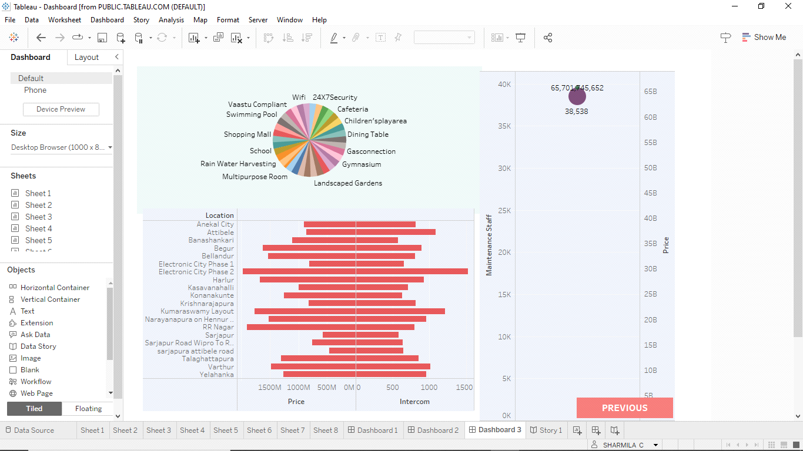

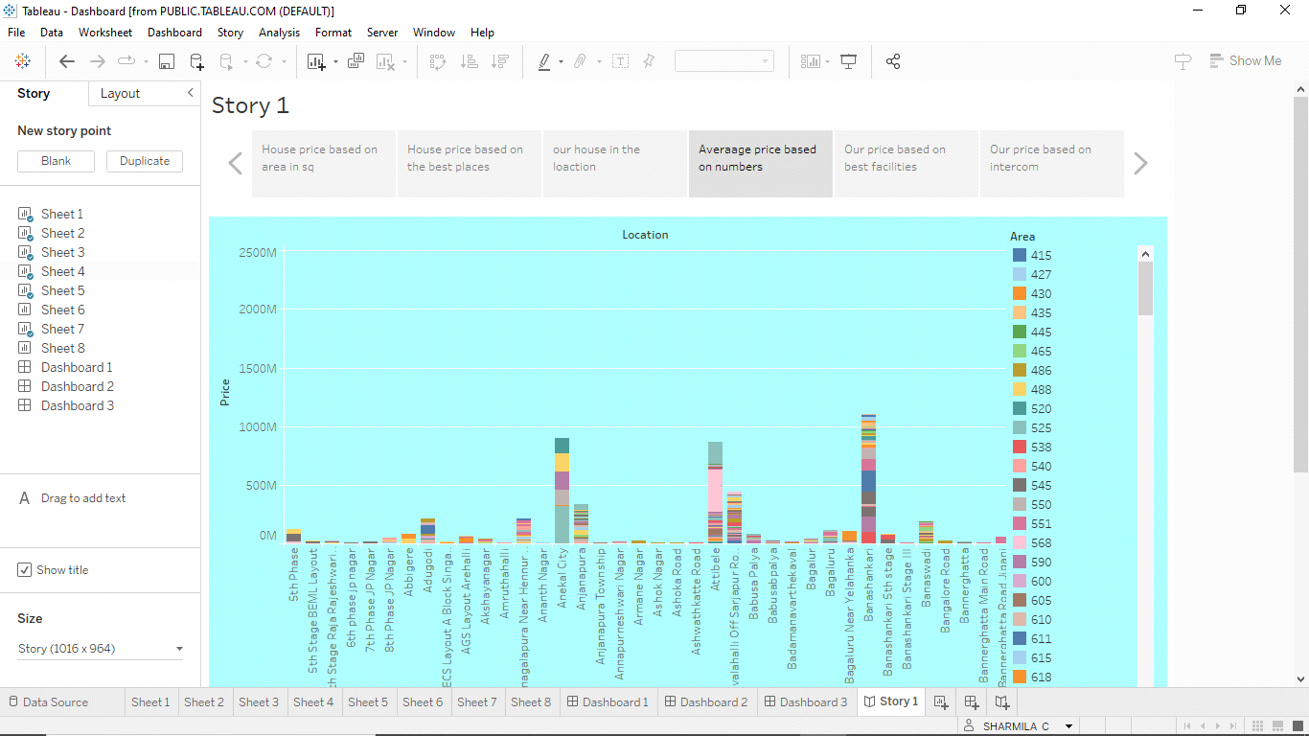

4. Advantages

* Informed Decision-Making
* Transparency
* Regional Insights
* Policy Guidance
* Data Visualization

Disadvantages

* Data Limitations
* Data Privacy
* Data Maintenance
* Technical Barriers
* Resource Requirements
* Market Volatility

5.Applications

*Real Estate Professionals:

Real estate agents and brokers can benefit from understanding the market dynamics, assisting clients with data-driven buying and selling decisions.

*Researchers and Academics:

Researchers can use the project's data for academic studies and research on housing markets, urban development, and economic trends.

*Financial Institutions:

Banks and financial institutions can use the project to assess the risk associated with property investments and make informed lending decisions.

*Media and Journalists:

Journalists can use the project's insights to report on housing market trends and provide valuable information to the public.

*General Public:

Anyone interested in the housing market, including renters, homeowners, and the general public, can access valuable insights into the real estate landscape in Indian metropolitan areas.

*Educational Institutions:

The project can serve as an educational resource for students and educators in real estate, economics, urban planning, and data analysis fields.

*Non-Profit Organizations:

Non-profit organizations focused on affordable housing and urban development can use the project to understand housing price dynamics and advocate for policy changes.

*Businesses and Retailers:

Retailers and businesses can use insights from the project to make location-based decisions for expansion or opening new stores, considering the economic profiles of different areas.

The project's applications are versatile and can serve as a valuable resource for a wide range of users, making informed decisions, influencing policies, and gaining a deeper understanding of housing markets in Indian metropolitan areas.

6. Conclusion

In conclusion, the project offers a valuable resource for understanding housing price trends in Indian metropolitan areas. By providing data-driven insights and user-friendly visualizations, it empowers individuals, investors, and policymakers to make informed decisions in the dynamic real estate market. This project represents a significant step towards transparency and better decision-making in the housing sector.

7.Future scope

Machine Learning Integration: Incorporate machine learning models to make predictions about future housing price trends, allowing users to antcipate market changes.

Advanced Analytics: Integrate more advanced statistical and econometric analysis to provide deeper insights into factors affecting housing prices, such as interest rates and employment figures.

User Customization: Allow users to customize the Tableau dashboards to tailor the data and visualizations to their specific needs and preferences.

Mobile Application: Develop a mobile app version of the project to provide on-the-go access to real-time housing market data.